HOW TO PURCHASE A LAPTOP

As a senior majoring in Computer Information Systems with dreams of being a great ‘Remote Full Stack Web Developer’, one of the most important starting points is having the absolute best equipment at my disposal. When considering a purchase as important as this, I felt the best way to go about it was to do it through a flowchart process (like I would a basic program) to guide me along the process based off of what I personally felt was most important. Below, is a flowchart I created in Microsoft Excel showing that process from beginning to end:
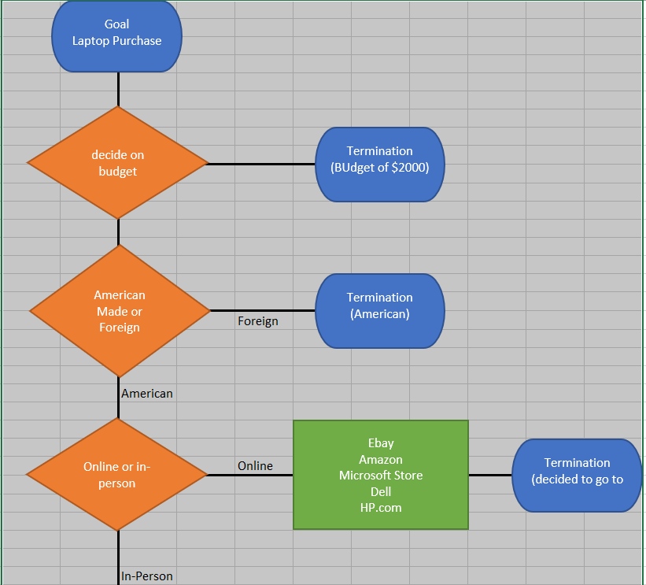
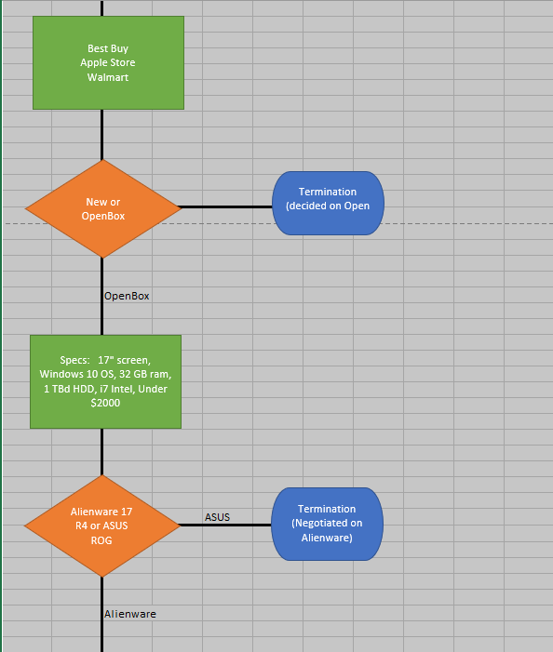
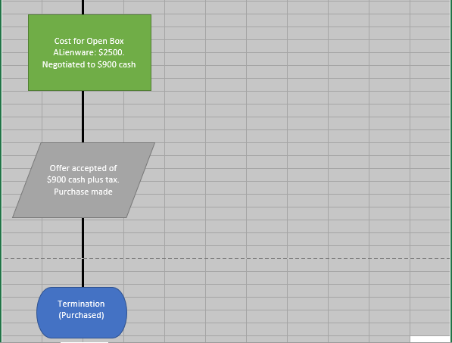
While this process was extensive, it does show the basic schematic of how I think a laptop should be purchased. One consideration was to find a quality unbiased review of my final choice(s) before I made the decision (Dingman, 2017One consideration was to find a quality unbiased review of my final choice(s) before I made the decision (Dingman, 2017). I also followed he basic from several websites on what should be considered tantamount in my decision (Freedman, 2020):
- Get a good GPU
- Consider being able to upgrade later
- Pick resolution of speed
- Get a quality keyboard
- Consider battery life (Freedman, 2020)
References
Dingman, H. 07 Aug 2017. “Alienware 17 R4 Review: Worth Its Weight In Performance.” Retrieved from: https://www.youtube.com/watch?v=YJ_PqEi9z5U
Freedman, A. 05 Jun 2020. “How To Buy A Gaming Laptop.” Retrieved from: https://www.tomshardware.com/reviews/gaming-laptop-buying-guide,5689.html

